Smart Tourist Guide

**Software Project Lab -2  
 Smart Tourist Guide**

**Submitted to** SPL-Coordinators  
 Institute of Information Technology  
 University of Dhaka

**Submitted By**

|  |  |
| --- | --- |
| Name | Roll |
| Muhabbat Sarker Eshan | BSSE0939 |
| Md Jahirul Hoque Rifat | BSSE0940 |

**Supervised by**Kishan Kumar Ganguly  
 Lecturer

Institute of Information Technology  
 University of Dhaka



Date:- 29 May, 2019

Letter of Approval

Dear sir,

This is to inform you that we, Muhabbat Sarker Eshan (BSSE 0939) and Md. Johirul Hoque Rifat (BSSE 0940) has successfully completed the project title “Smart Tourist Guide”. It was not that easy to complete this project. We faced a lot of difficulties while doing the project. But we worked together and made it easy. We would like to thank all who helped us in gathering the required information.

Therefore, we would like to request you to go through the project and approve the project so that we can submit it.

Supervised by:

Kishan Kumar Ganguly

Lecturer

Institute of Information Technology

University of Dhaka

LETTER OF TRANSMITTAL

29th May 2019  
SPL-2 Coordinator,  
Institute of Information Technology  
University of Dhaka.  
**Subject: Submission of SPL-2 SRS term report on Smart Tourist Guide.**Sir,  
With due respect, we are submitting the report on the above topic you assigned to us. In this report, we have given our best effort albeit some shortcomings. We earnestly hope that you would excuse our errors and oblige thereby.

Yours sincerely  
Muhabbat Sarker Eshan –BSSE0939  
Md Jahirul Hoque Rifat – BSSE0940

3nd Year, 5th Semester, 9th Batch  
Institute of Information Technology  
University of Dhaka  
Session: 2015-16

**Acknowledgement**

We are highly indebted for getting such a tremendous opportunity to develop an android application on Smart Tourist Guide. We would like to thank our supervisor, Kishan Kumar Ganguly, Lecturer, Institute of Information Technology, University of Dhaka, for giving us guidelines about how we can develop an application.

Finally, we like to thank the Almighty Allah for completing the project.

**Abstract**

This document initially describes the steps that the user should follow while using this software. It guides the user how to use the system.

**Table of contents**

Abstract………………………………………………………………5

Introduction…………………………………………………………..7

System Requirements………………………………………………..7

Authentication……………………………………………………….7

Stakeholders…………………………………………………………7

User profile………………………………………………………….13

Recommendation……………………………………………………36

Notification………………………………………………………….39

Conclusion…………………………………………………………..40

**List of figures**

Figure 1: sign in form 8

Figure 2: sign up form 9

Figure 3: email verification mail 10

Figure 4: forget password 11

Figure 5: reset password 11 Figure 6: logout 12

Figure 7: category 13

Figure 8: first page1 14

Figure 9: Profile Data 15

Figure 10: Resort Category    16

Figure 11: Elegna Resort   17

Figure 12: Water Fall list 18

Figure 13: Baklai waterfall location    19

Figure 14: List of Hill 20

Figure 15: Keokradong Hill    21

Figure 16: List of Museum   22

Figure 17:Bagabandu Memorial Museum location    23

Figure 18: Cinema Hall list    24

Figure 19: Star Cineplex location 25

Figure 20: Café list    26

Figure 21:D-café location    27

Figure 22: Zoo list 28

Figure 23: Mirpur zoo Location 29

Figure 24: Restaurant list  30

Figure 25: Restaurant location 31

Figure 26: List of sea-beach     32

Figure 27: Sea-beach location   33

Figure 28: List of park 34

Figure 29: Park location   35

Figure 30: Cf formula    36

Figure 31: Recommended Places 37

Figure 32: Recommended place location    38

Figure 33: Verification Email 39

**1.Introduction**

This project is about user manual and demonstration details of “Smart Tourist Guide”. This overall document will help each and every person related to this project to have a better idea about the project and its requirements. A Smart Tourist Guide is an android application which will recommend users about the places or things, users can search places according to their interest and routes to the destination. The long time which tourists waste on searching for the better places like hotels, museums, parks etc. for their enjoyment in the new city which is totally unknown to them will get reduced, if they use this application. This idea is useful for all those who love to travel in a new city on a regular basis. This project includes some features like user profile, recommendation, traveling area search, show routes to destination places, place rating and user feedback etc.

**2. System Requirements**

2.1 User Requirements - Android Phone (android version 5.1 and above).

2.2 Administrator Requirements – Firebase.

**3. Stakeholders**

All the people who sign in this android application are the stakeholders of this application.

**4. Authentication**

4.1 Sing In

For sign in to the application, a sign in form will be shown with two fields to get email and password. If the user get valid input a verification mail will be sent. After confirmed verification sign in process will successfully done.

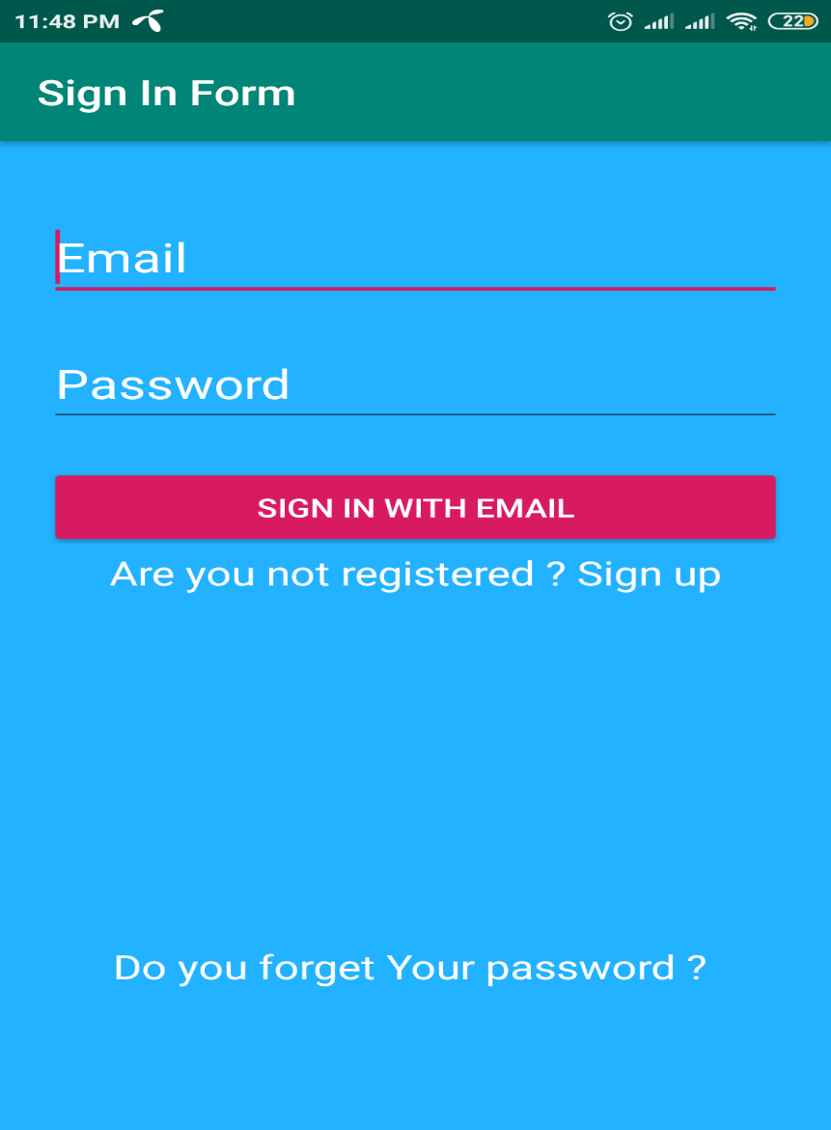

Fig 1: sign in form

4.2 Sign Up

For sign up users need to click sign up. A form will appear with various fields to get valid Information. User should fill these fields up and click sign up button.

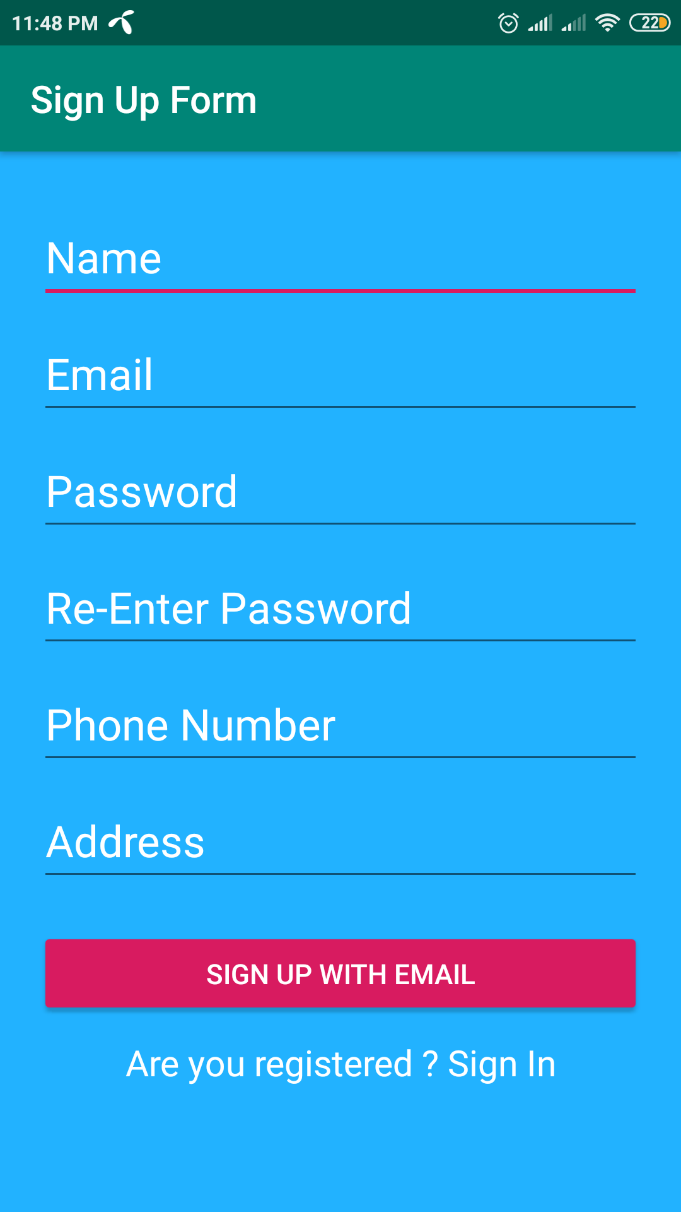

Fig 2: sign up form

A verification mail is sent to user. When user click the link sign up is successful.

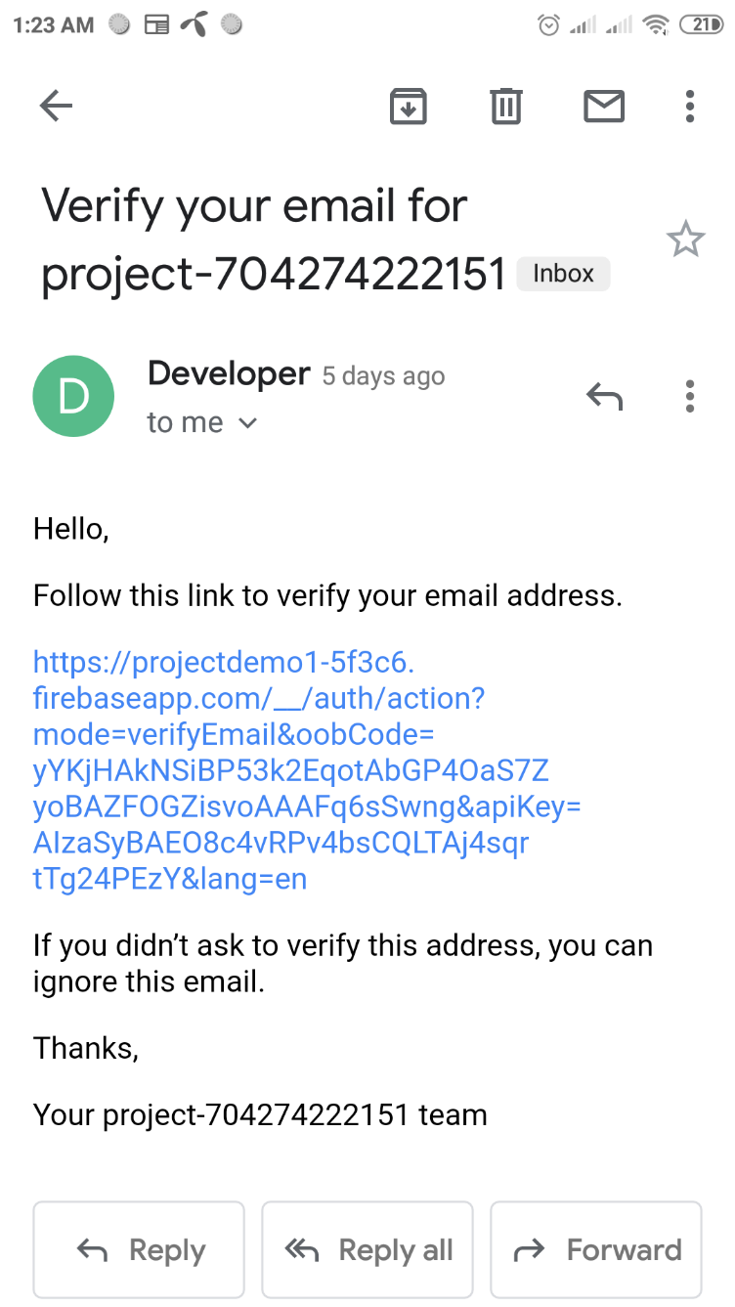

Fig 3: email verification mail

4.3 Forget Password

To get recover password user must click forget password. A form will be shown which will take email address and send mail to reset password via this email. User can able to reset password then .

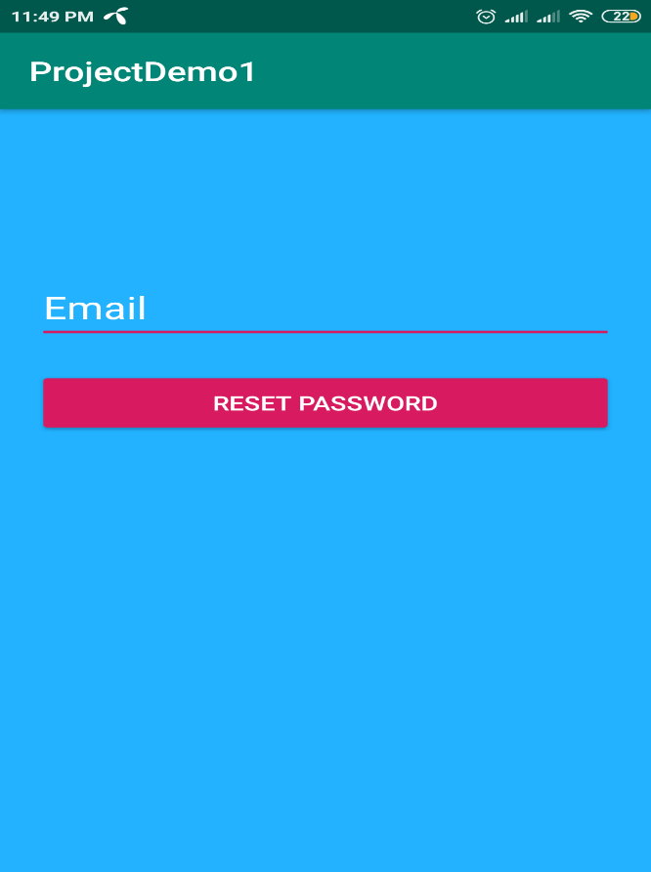

Fig 4: forget password

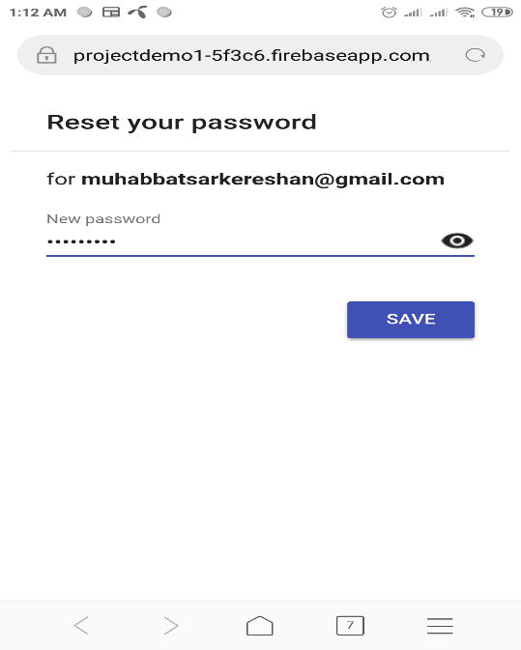

Fig 5: reset password

4.4 Sign Out

To sign out from this application user must need to click log out button.

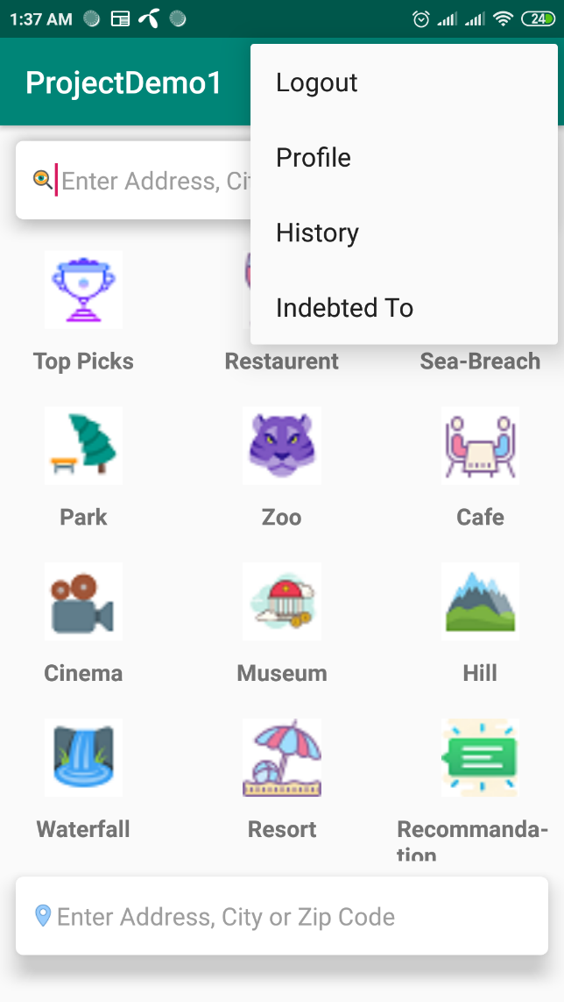

Fig 6: logout

**5. User Profile**

After successful sign in the below page will be shown where at the bottom device current location will be shown.

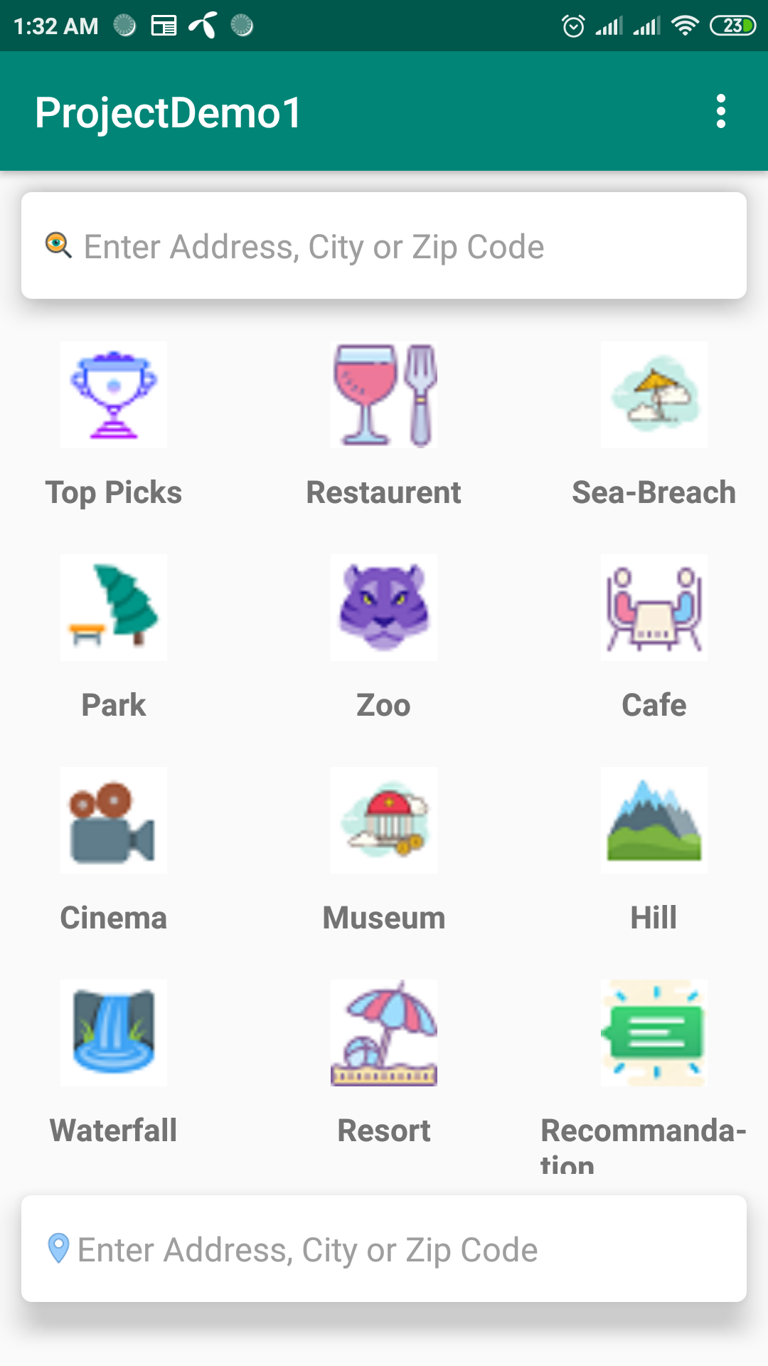

Fig 7: category

By clicking the right corner icon we can see the following:

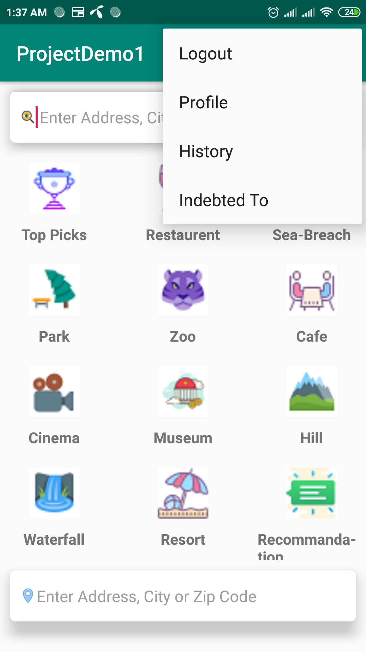

Fig 8: first page1

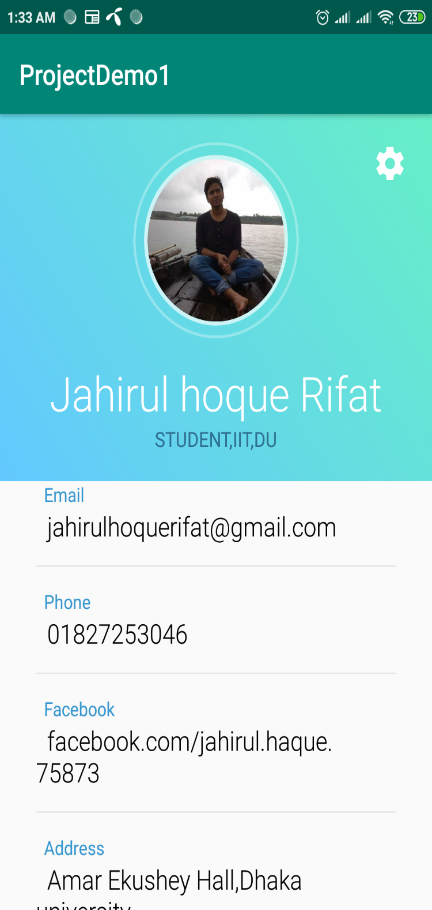

Fig 9: profile data

By selecting the resort from category we can see the following:

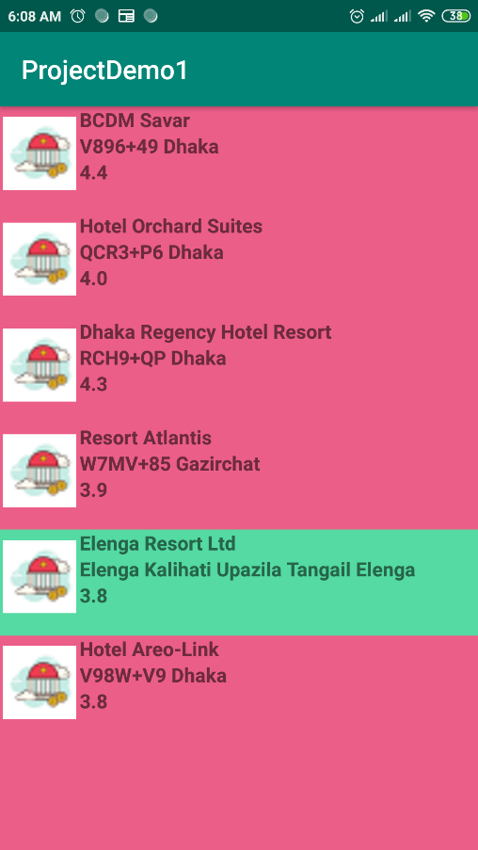

Fig 10: resort category

Select a resort from resort list we can see the position of this place in google map.

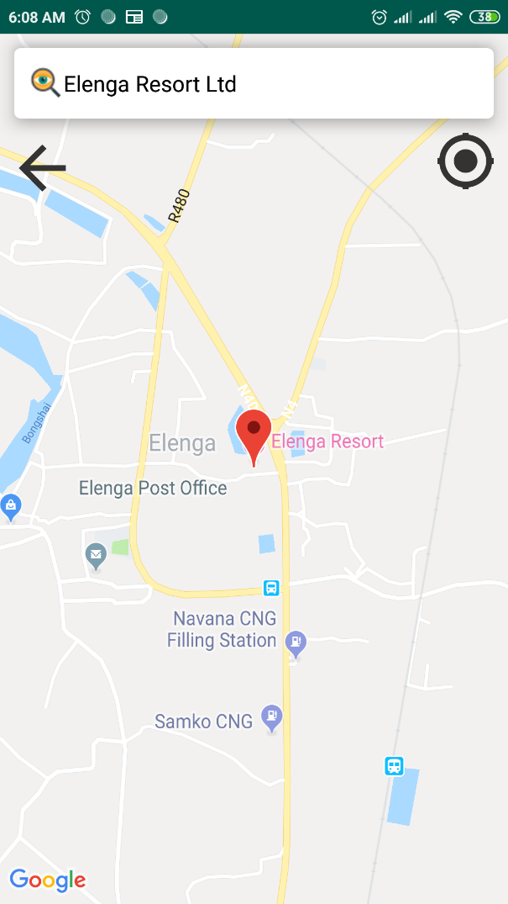

Fig 11: elenga resort

After selecting waterfall category we can see the waterfall list .

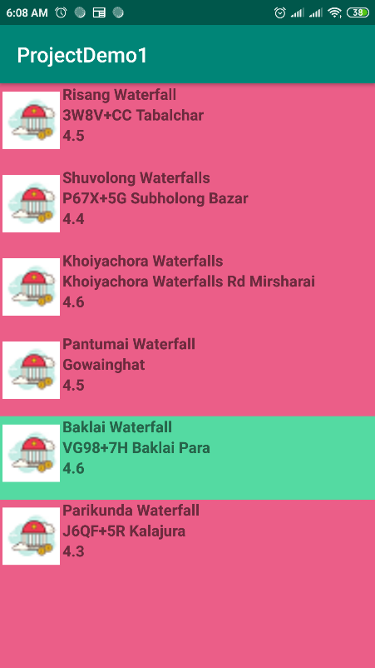

Fig 12: waterfall list

Select a waterfall from list we can able to see the waterfall location in map.

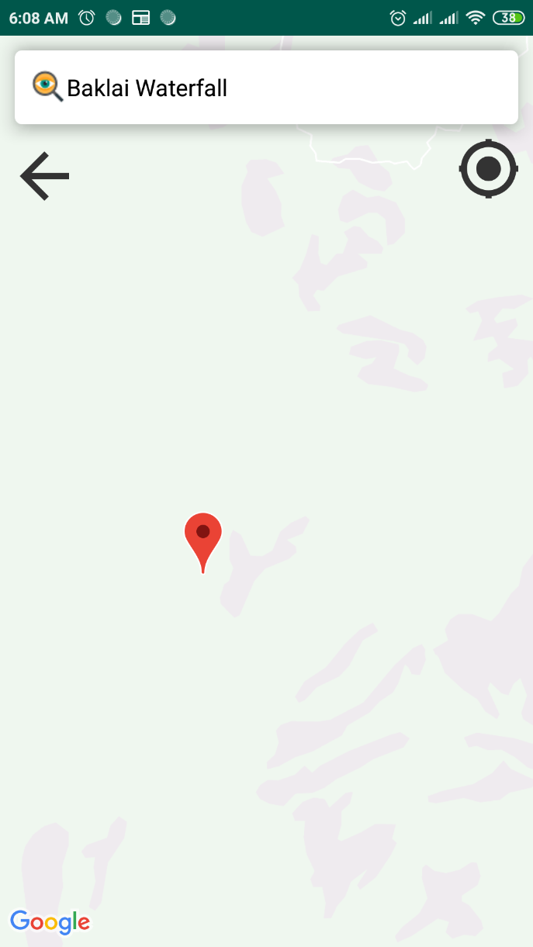

Fig 13: location of waterfall

Selecting hill category we can see the list of hill.

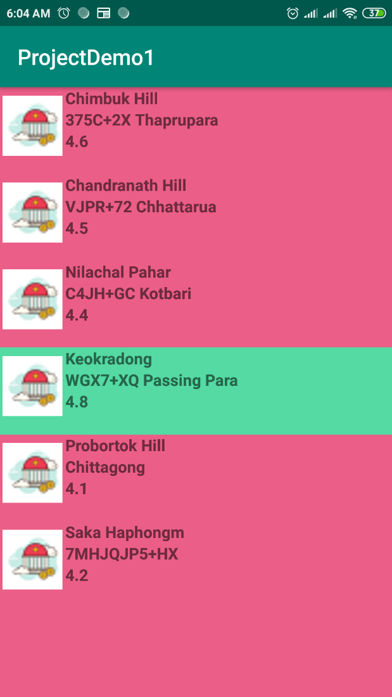

Fig 14: list of hill

By selecting a particular hill from the list we can see the hill location in map.

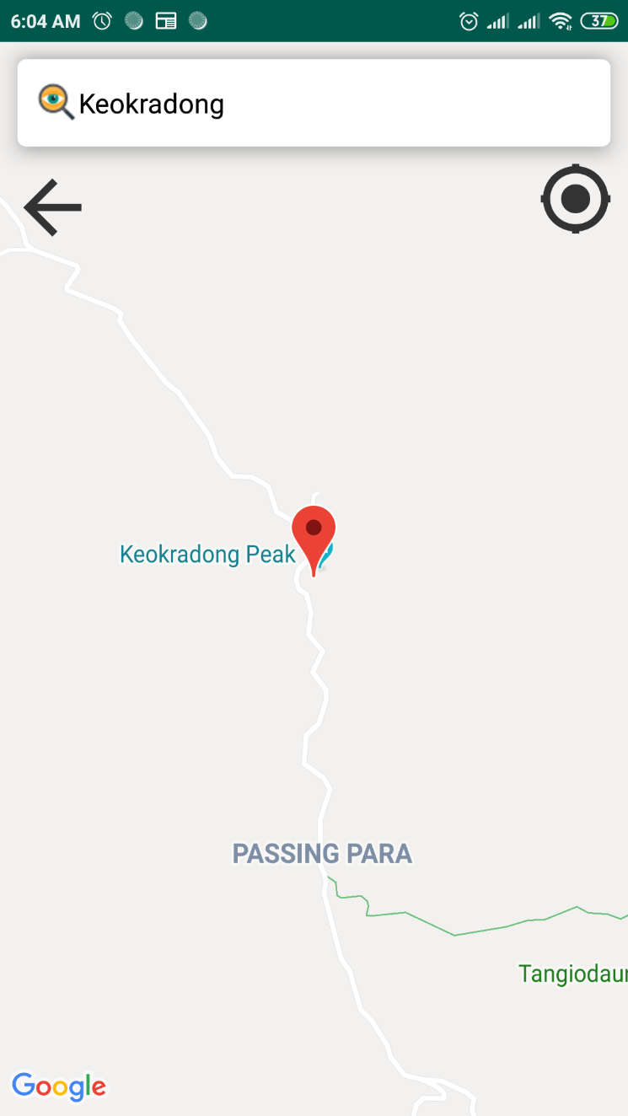

Fig 15: location of hill

By selecting a museum we can see the list of museum.

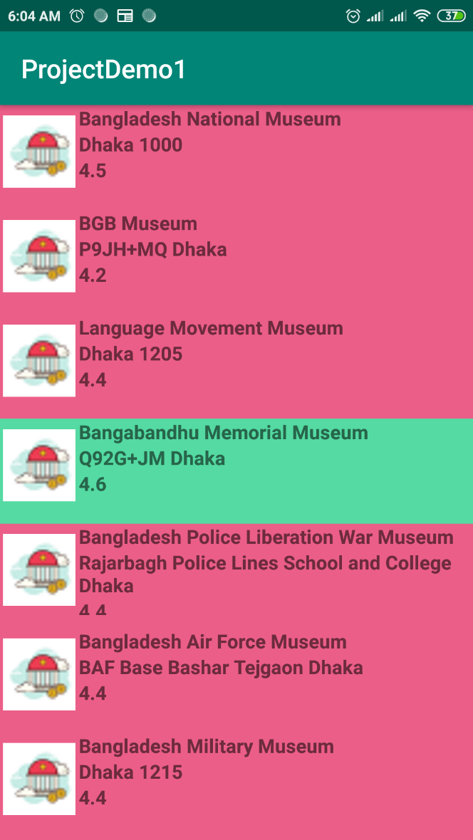

Fig 16: list of museum

Select a particular museum from the list we can see the museum location on the map.

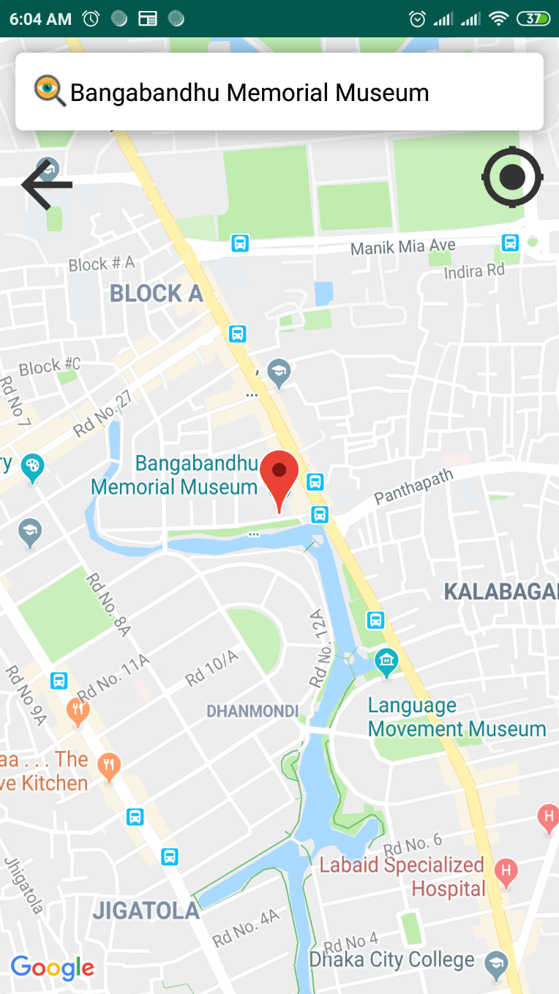

Fig 17: location of museum

By selecting cinema category we can see the cinema hall list.

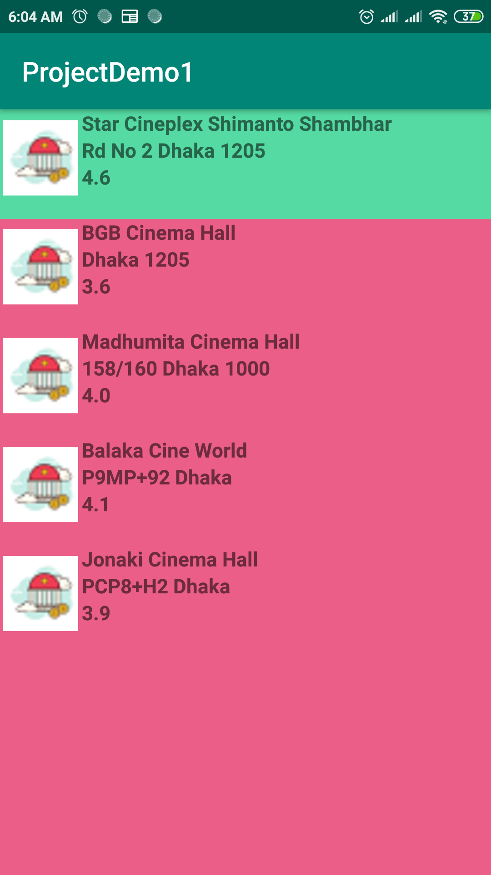

Fig 18: cinema hall list

By selecting a particular cinema we can see the cinema hall location on map.

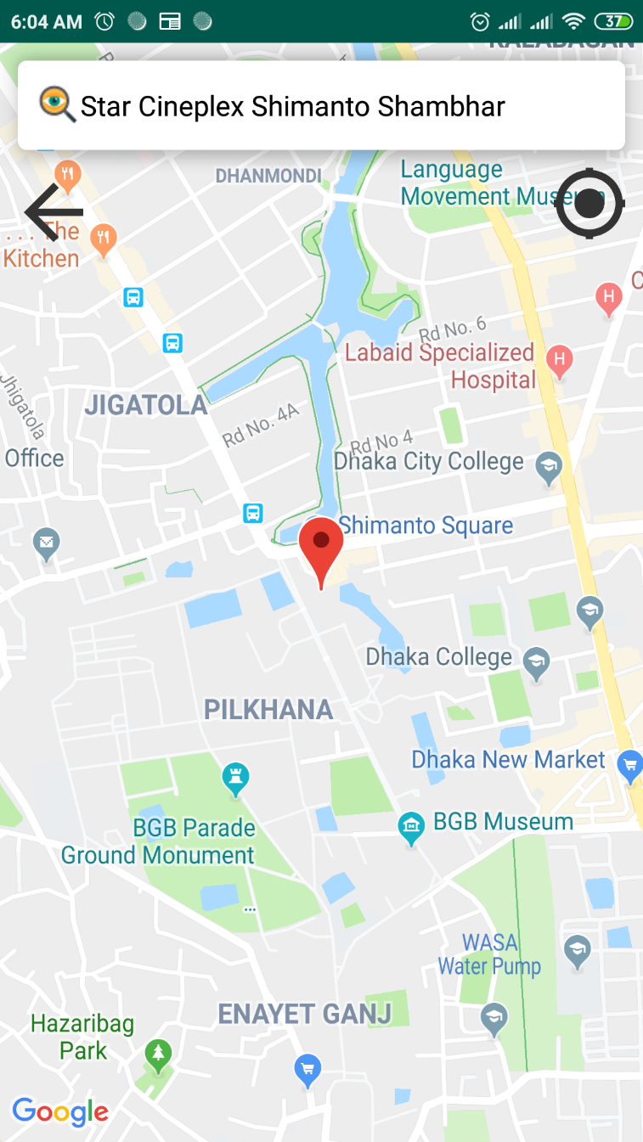

Fig 19: cinema hall location

By selecting café category we can see the café list.

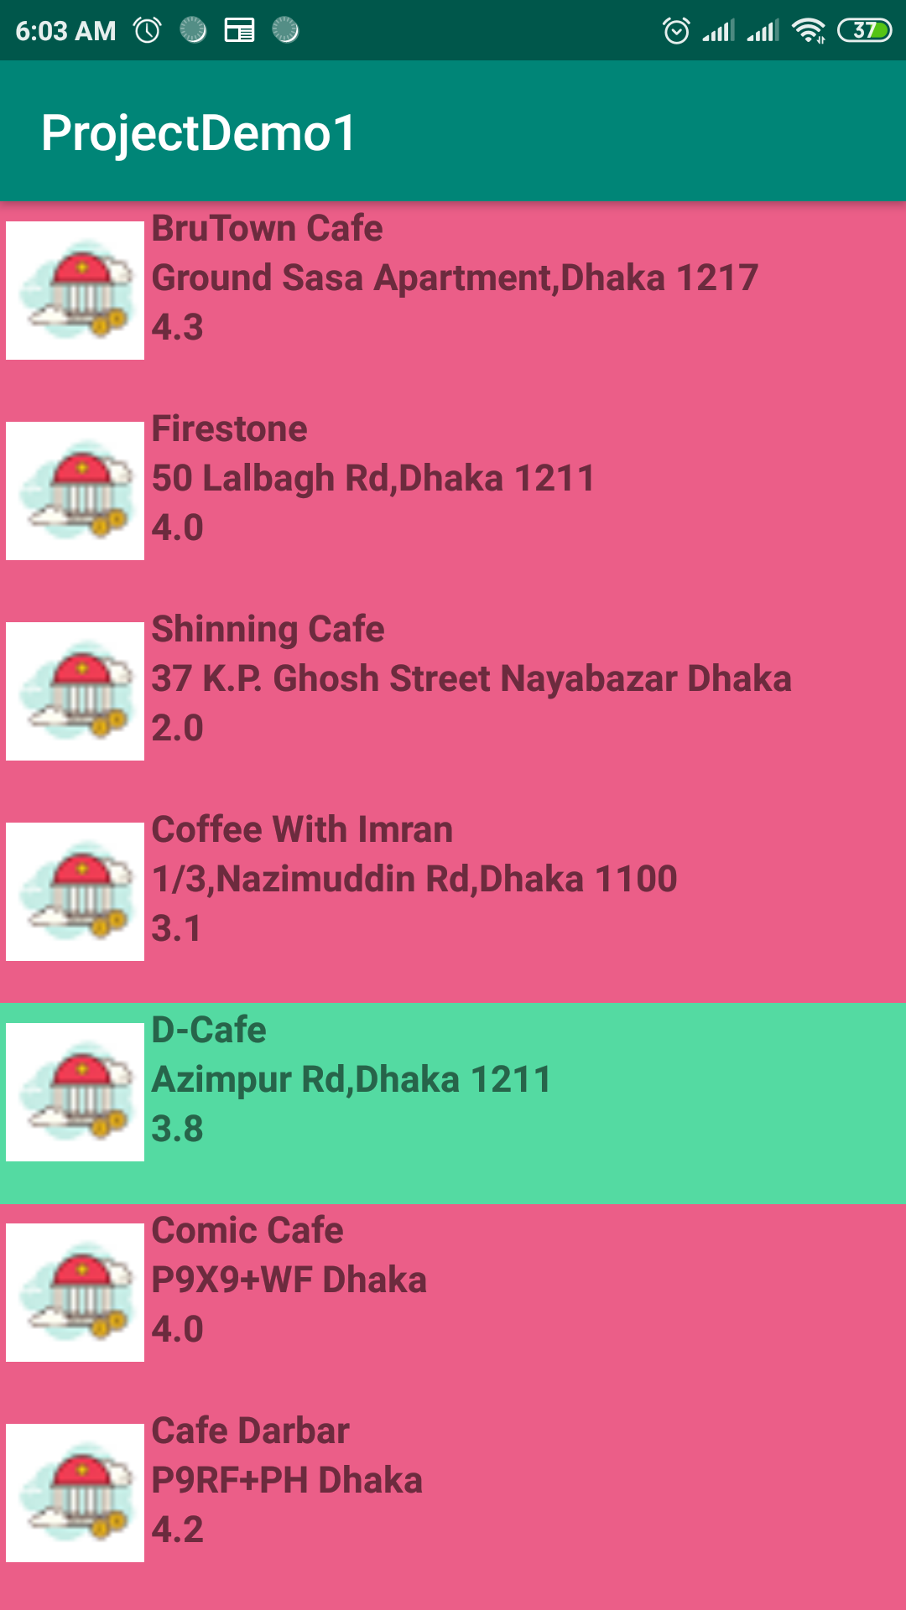

Fig 20: café list

Selecting a particular café from the list we can see the café location.

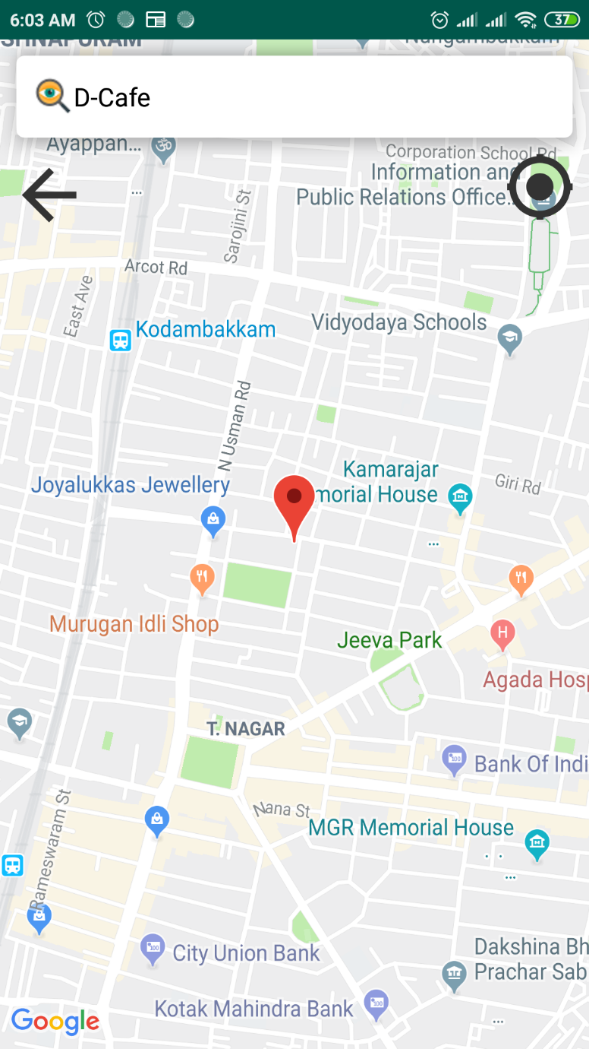

Fig 21: café location

By selecting zoo category we can see the zoo list.

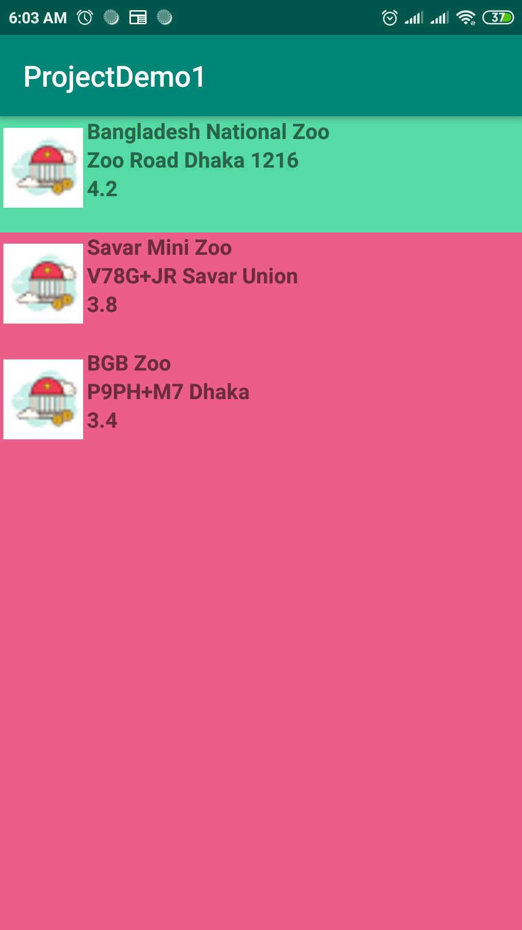

Fig 22: zoo list

Selecting a particular zoo we can see the zoo location.

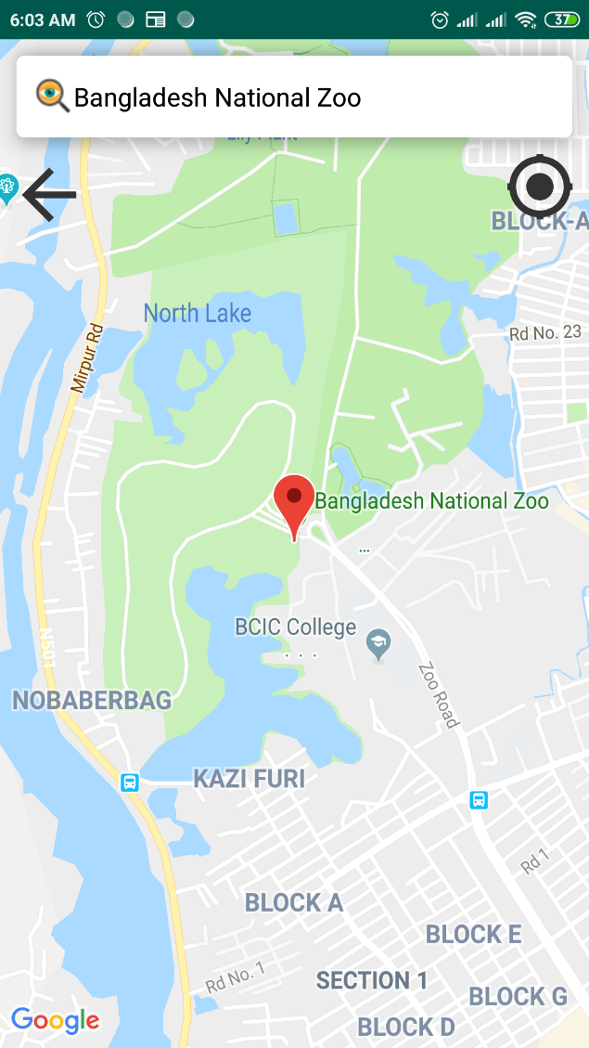

Fig 23: zoo location

Selecting restaurant category we can see the list of restaurant.

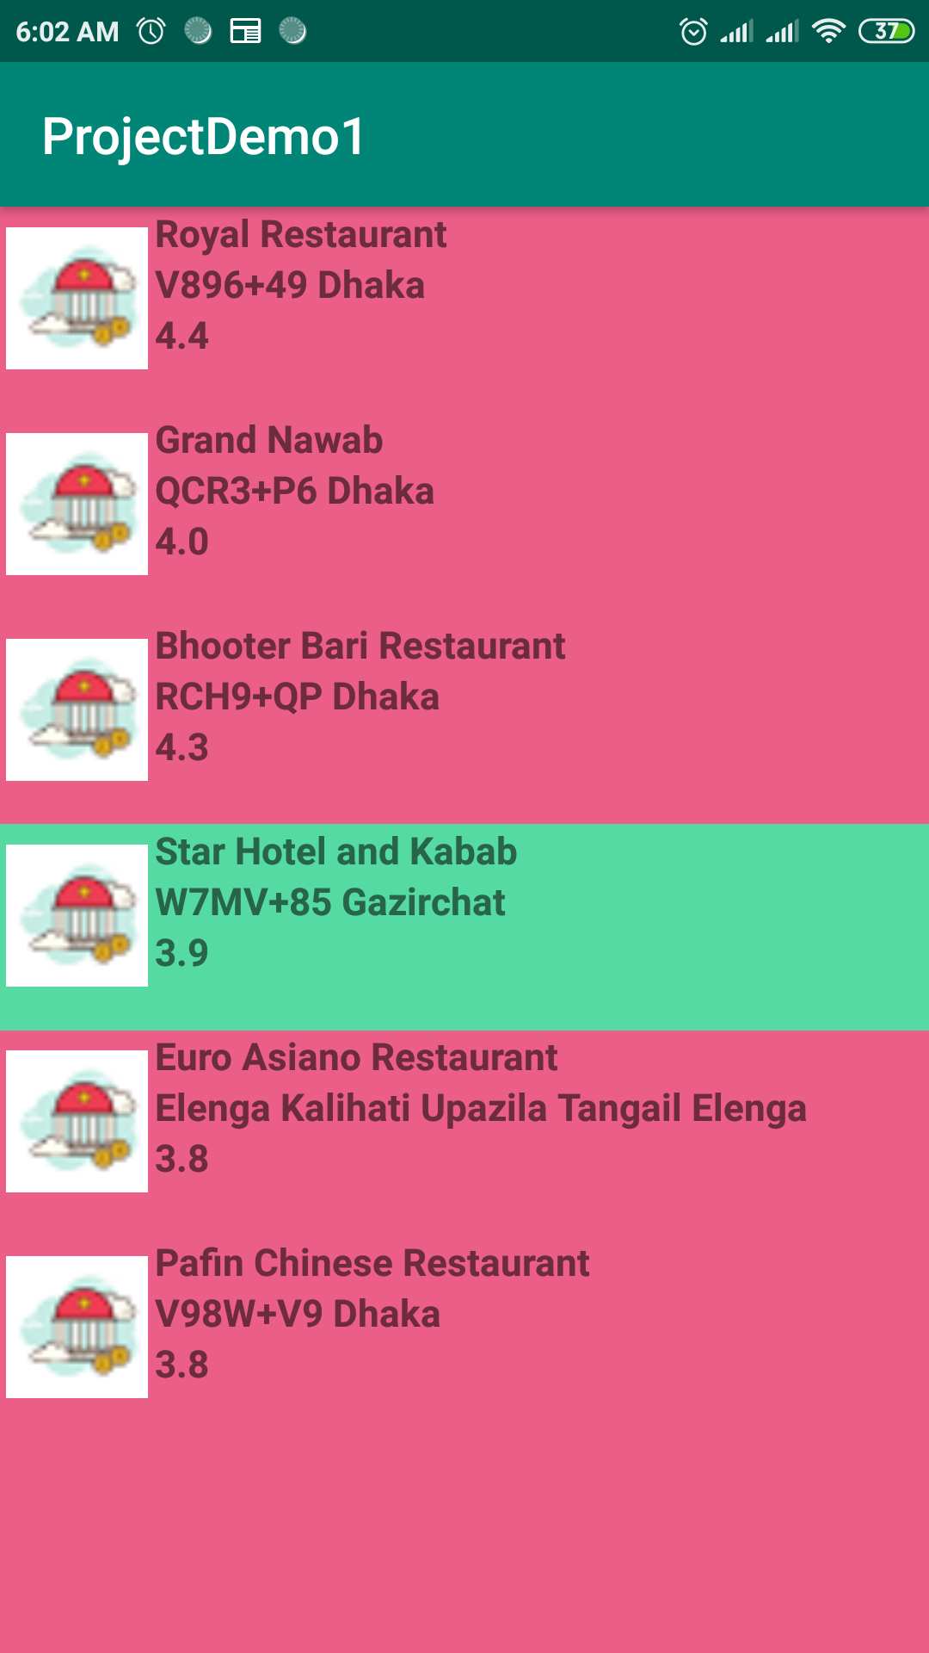

Fig 24: restaurant list

Selecting a particular restaurant we can see the restaurant location.

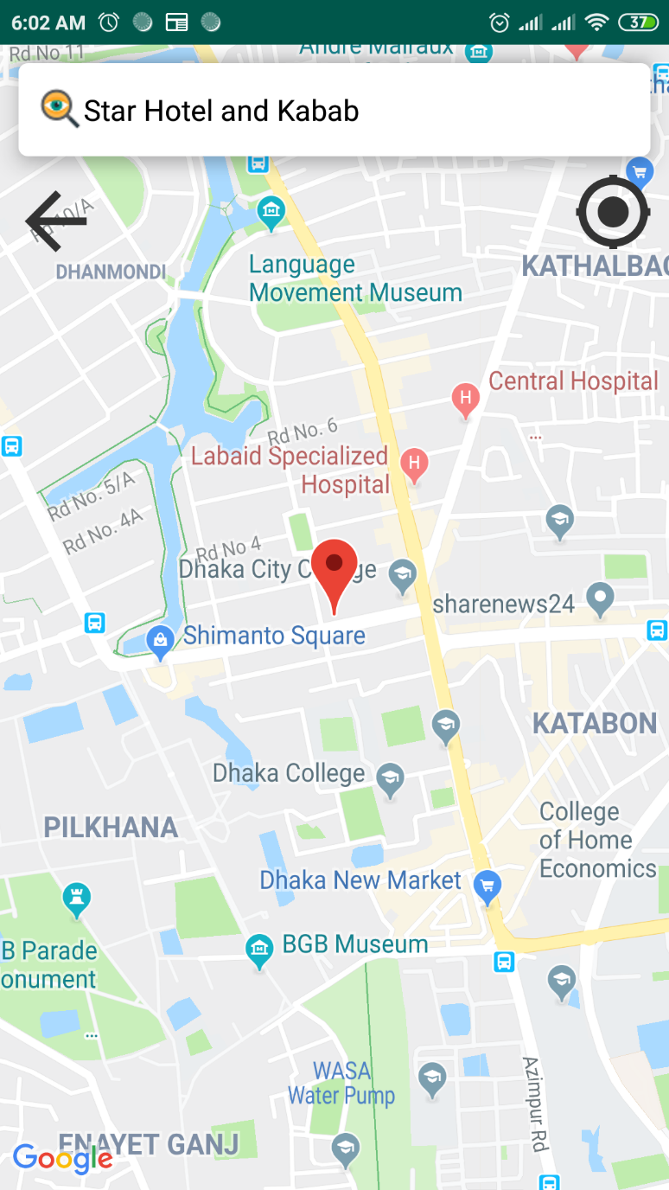

Fig 25: restaurant location

By selecting sea beach category we can see the list of sea beach.

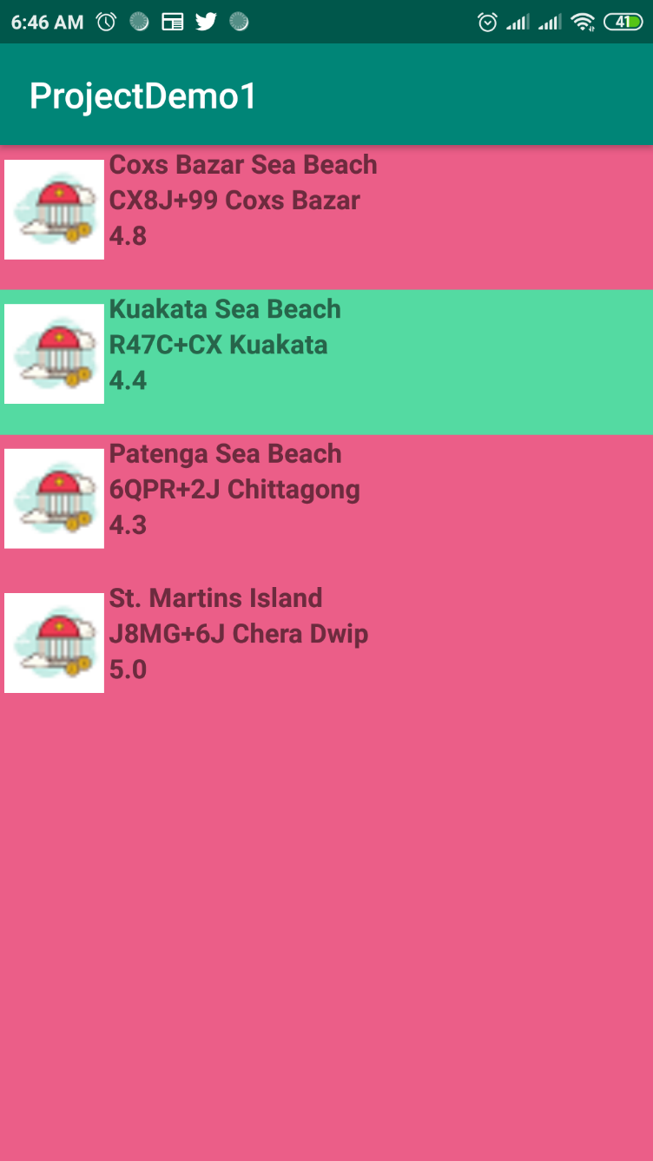

Fig 26: list of sea-beach

By selecting a particular sea-beach we can see the location of that sea-beach.

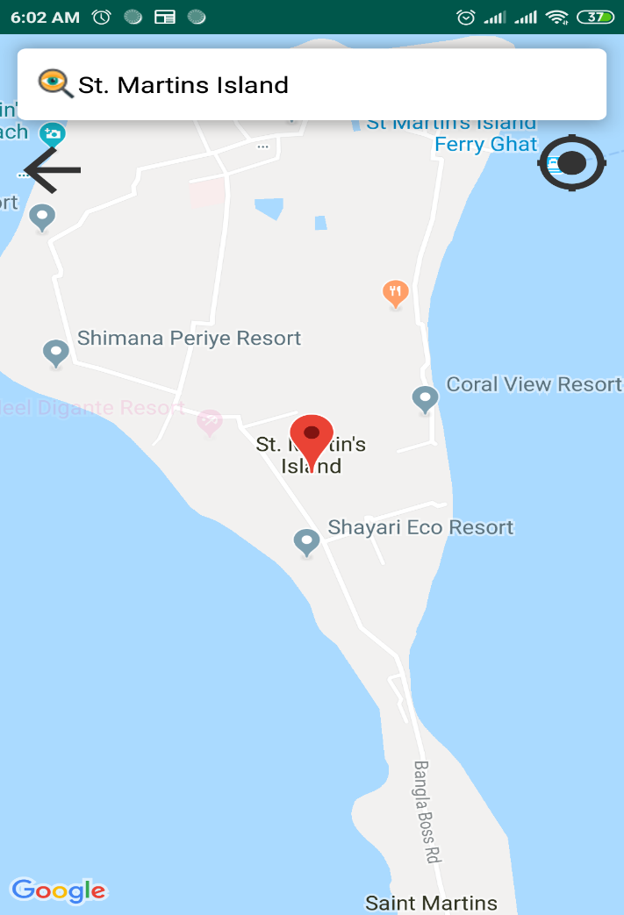

Fig 27: sea-beach location

By selecting park category we can see the list of park.

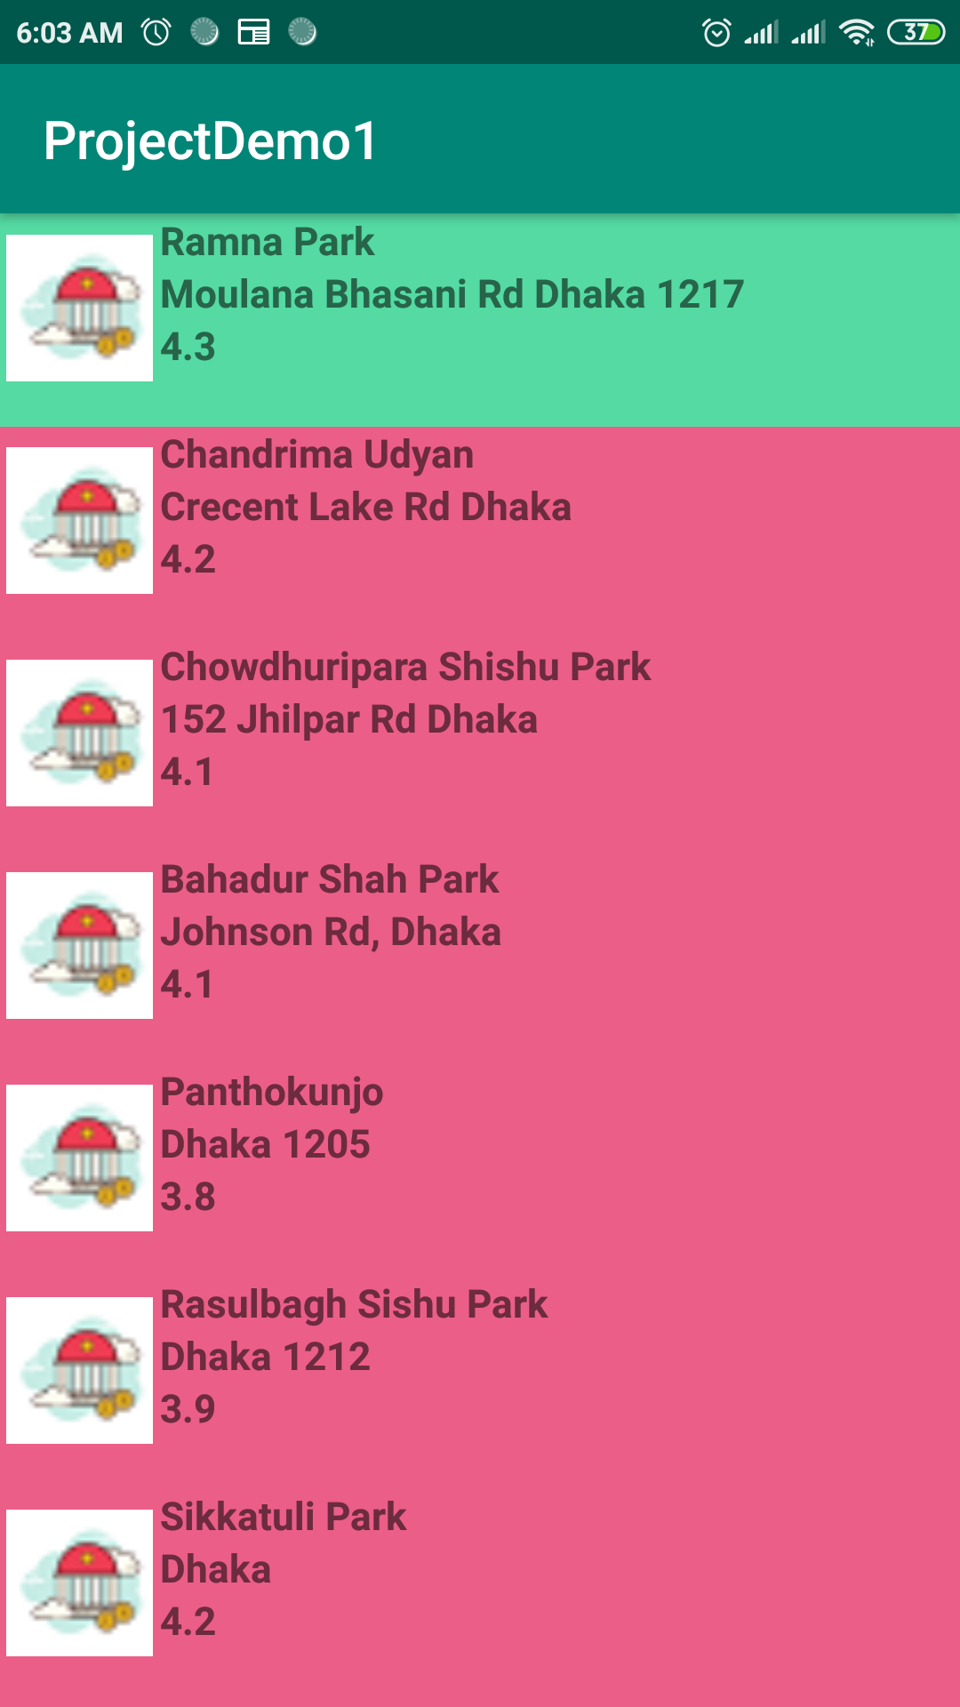

Fig 28: list of park

By clicking on a particular park we can see the park location on map.

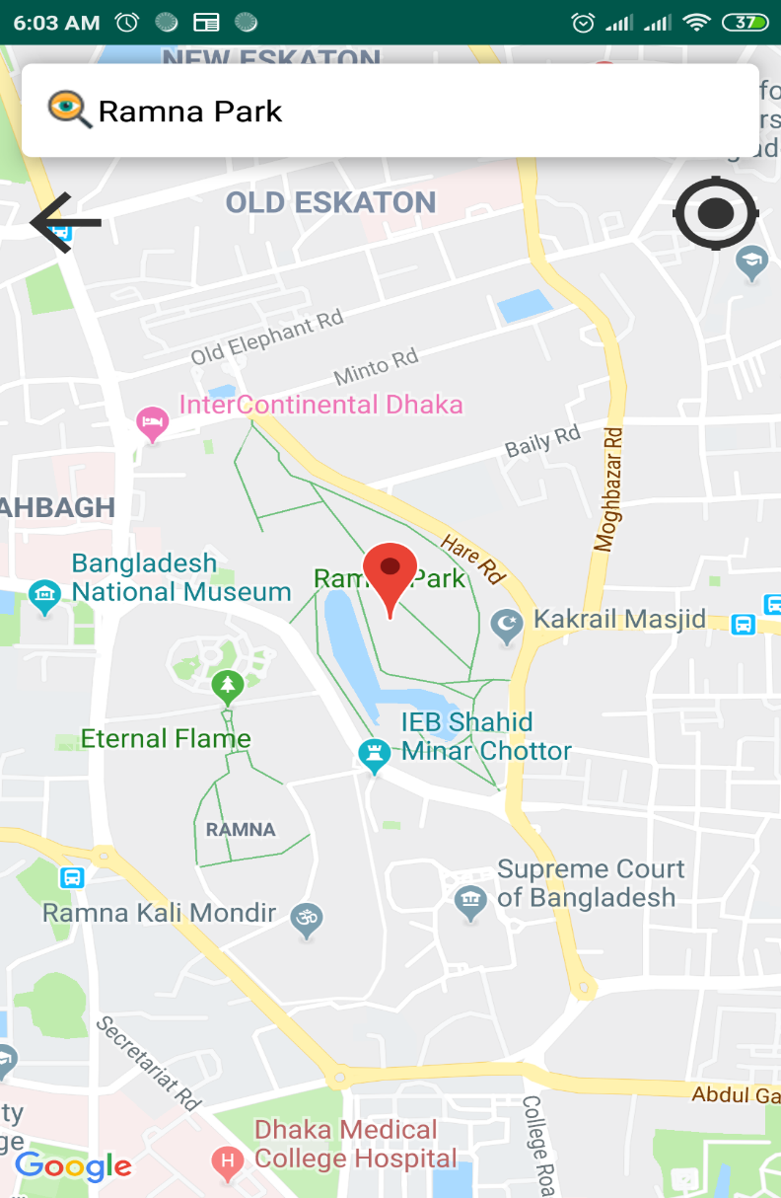

Fig 29: park location

**6. Recommendation**

To recommend a place we need to access the list of user previous visited places visited places. Collaborative filtering (CF) is a technique used by [recommender systems](https://en.wikipedia.org/wiki/Recommender_system) .Collaborative filtering is the process of filtering for information or patterns using techniques involving collaboration among multiple agents, viewpoints, data sources, etc. Collaborative filtering is a method of making automatic [predictions](https://en.wikipedia.org/wiki/Prediction) (filtering) about the interests of a user by collecting preferences or [taste](https://en.wikipedia.org/wiki/Taste_(sociology)) information from [many users](https://en.wikipedia.org/wiki/Crowdsourcing) (collaborating). The underlying assumption of the collaborative filtering approach is that if a person *A* has the same opinion as a person *B* on an issue, A is more likely to have B's opinion on a different issue than that of a randomly chosen person. For example, a collaborative filtering recommendation system for [television](https://en.wikipedia.org/wiki/Television) tastes could make predictions about which television show a user should like given a partial list of that user's tastes (likes or dislikes). Here actually we find that which user’s data is closest to our specific user. Then make prediction using the nearest one. If the data is missing from that point of the nearest user, we iterator our loop for next prediction.

To find the closest user we use the below formula: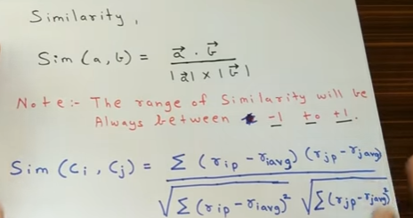

Fig 30: CF formula

Finally we find the below recommend place for the demo user.

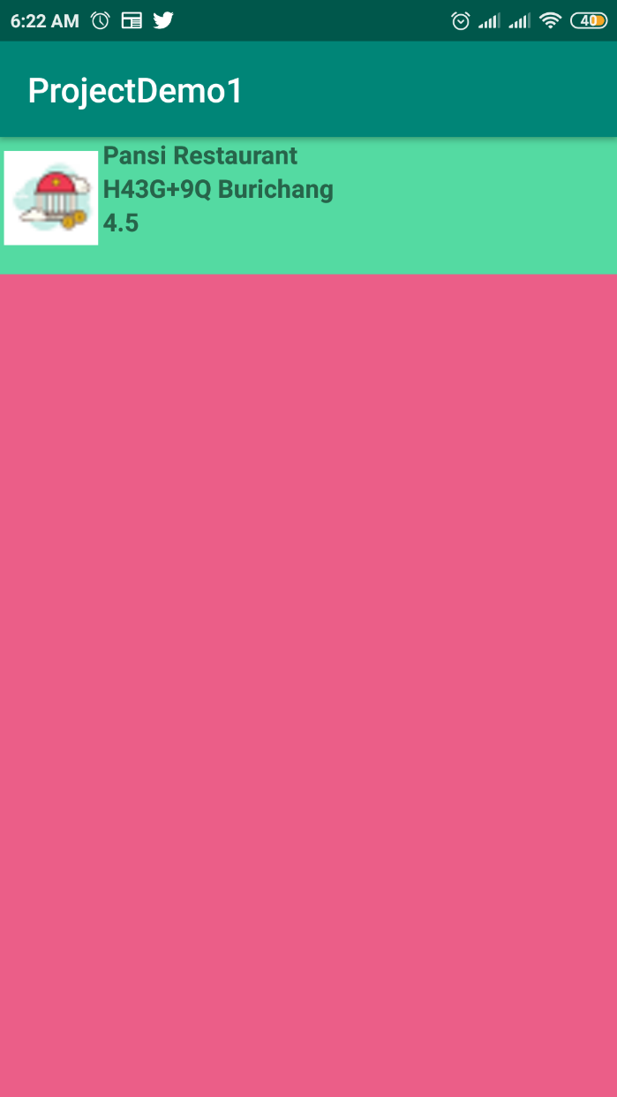

Fig 31: recommended place

To see the recommended place location user need to click on the place.

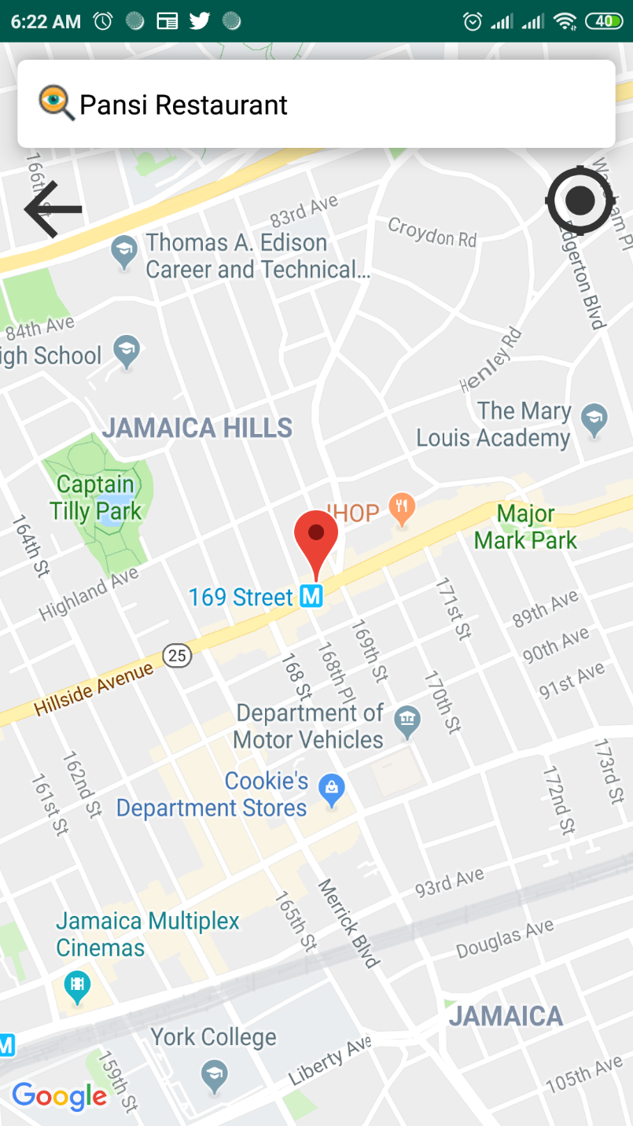#

Fig 32: recommended place location

**7. Notification**

A user will get notify by the administrator when he/she sing up in the application as well as password recovery and recommendation.

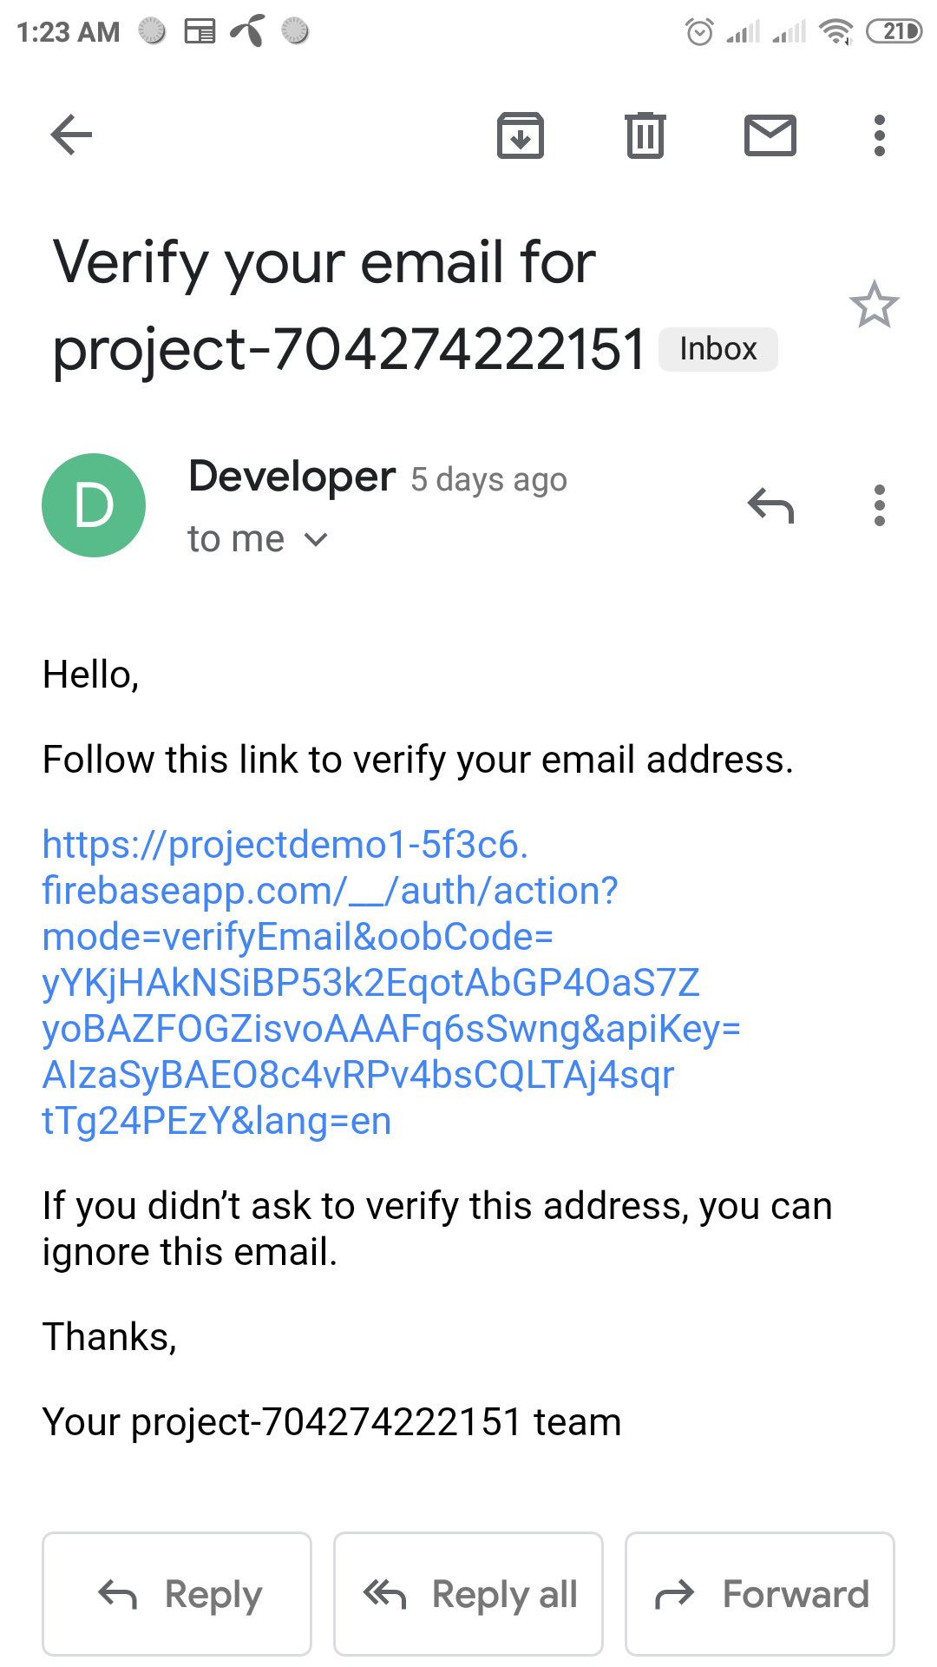

Fig 33: verification email

**8. Conclusion**

By following this user manual, a user can smoothly use this application. We tried our level best to describe the user manual as simple as possible.

Github link: https://github.com/bsse0939/SPL-II